Team508: Structural and Thermal Management of an Automotive Battery
Concept Selection
Taylor Bethmann
Austin Robertson
Kaleb Sands
Mark Hibyan
Skyler Heft
FAMU-FSU College of Engineering

Structural and Thermal Management of an Automotive Battery
Concept Selection
Concepts previously generated are ranked against one another in terms of their ability to accomplish the goals of the project. These concepts are analyzed through various selection tools, House of Quality, Pugh chart, and Analytical Hierarchy Process (AHP), to evaluate which design best satisfies the functions and targets of our battery system.

Concepts
The concepts below were previously generated in order to meet the goals of the project, using a decomposition of the project functions and target analysis. A description of each is presented to aid in the selection process and add background information pertinent to each concept.

Passive Air Cooling
Passive air cooling refers to using non forced air to cool the battery modules. Using air as the car drives saves energy by allowing the air to enter and exit based on the cars speed. There are several ways to apply this method, one method of doing this is to have air intakes all around the box so air may enter and exit from anywhere. Another idea is to have an air intake on the side of the car and a tube leading into other box so the air flows in and exhausts out another side. Another idea for this is turning the box into a heat exchanger with the modules having fins attached through the box to them and cooling these fins while the car drives. The key idea of this concept is that the cooling system does not draw any power from the battery.

Forced Air Cooling
To force the air there would be a device that moves the air through the box and draws power from the batteries. The fans can have covers to keep dust and particles out while taking in air into the box and another fan exhausting the air out of the box. This draws extra power from the battery, but would allow for variable cooling, based on the temperature of the modules.

Liquid Cooled with Compressive Plates
This uses a pump and liquid to cool compressive plates around the module. The cooled plates cool off the modules and provide cooling for the battery. This requires power draw from the battery and can be dangerous because batteries and liquids can be volatile. It is very effective at cooling the battery as liquid can be cooled to very low temperatures and adjusted to keep the modules at the optimal temperature. Also, the lifecycle of the modules will be greatly increased.

Cold Plate
This is based on the idea of heating up a plate using current and having a heat exchanger attached to the plate that draws the heat out and cools the plate. This plate is than placed between or near the modules so that they are cooled. This requires more power from the battery, but cools effectively and can help the life cycle of the battery pack.

Phase Change Material
Phase change materials change their thermal conductivity based on the temperature so they absorb the heat and keep the batteries at a constant temperature. There are many phase change materials although they are expensive and most are flammable so that bring s up the concern of safety. This idea keeps the modules at a fairly constant temperature as the race goes on as there is a limit to the heat that the phase change material can store. This idea requires no extra power draw from the battery.

House of Quality
House of quality is a tool used to infuse the voice of the customer into the design selection. The house of quality table, located in Table 1, displays the comparison between the needs stated by the customer and the engineering characteristics associated with the concepts in the selection process.
To begin, the customer requirements are ranked by importance on a 1-5 scale, where 5 is the highest priority and 1 is the lowest. The engineering characteristics associated with the project objectives are then compared to the customer requirements, using a similar 1-5 scale. In this case, a 5 would signify that the characteristic is slightly related, and if they are not related then the cell is left blank. These values are multiplied by the ranking of the associated customer requirement, so that they are weighted appropriately. Next, the scores are summed up and weighted against that the other characteristics, to rank their importance based off the customer requirements. In this last ranking, the most important characteristic is given a 1 and then it decreases from there. As a result, Safety and Heat Dissipation are the highest priority engineering characteristics. From this, the generated concepts can be analyzed with the understanding that Safety and Heat Dissipation are vital characteristics for any of the selected designs.

Pugh Chart
The Pugh chart is a method used in comparing the concepts generated against one another, to identify the most promising design. This method begins by comparing the concepts against a datum or reference technology, to determine whether the concepts are better or poorer than existing systems. The importance of each engineering characteristic, as determined in the House of Quality, was kept in mind throughout the comparison of the concepts, to ensure Safety and Heat Dissipation are being weighted into the selection. The three Pugh charts produced for this project are shown in tables 2 through 4.
The first Pugh chart uses the Nissan Leaf battery box as the datum. Because the modules used in our battery are Nissan Leaf modulus, we found it appropriate to use as a reference design. The engineering characteristics of our concepts are then compared to the datum, using a plus (+) to signify that it is superior, a minus (-) signifying that it is poorer, and an S to signify that they are the same. The total amount of pluses and minuses are then summed for each concept to determine which is a better design.
Next, a second Pugh chart is created using the best concept, that had the greatest number of pluses and least number of minuses, as the datum. Because the concept poses as the greatest design when compared to the reference technology, it needs to be compared to the other concepts to ensure it is superior to those as well. In this case, the Passive Air-Cooling concept is used as the datum and is compared to the other top three designs, Forced Air Cooling, Cold Plate, and Phase Change Material. Similar to the first chart, the number of pluses and minuses for each concept is summed. As a result, the Cold Plate is only concept that has a greater number of pluses than minuses. Due to this, the Cold Plate has to be evaluated against the other concepts to determine if it is a better design.
The third Pugh chart is created to evaluate if the Cold Plate concept is better than the other concepts. Because the Cold Plate had the highest number of pluses in the second Pugh chart, it is used as the datum. The same concepts used in the second Pugh chart are used in the third as well. Again, the concepts are ranked against the datum in reference to the engineering characteristics and the pluses and minuses are summed. In the summation of this Pugh chart, it can be seen that the Passive Air Cooling has the largest number of pluses and least number of minuses. Because Passive Air Cooling is the better concept as a result of two of the three Pugh charts, it is considered the most preferred design.

Analytical Hierarchy Process (AHP)
The AHP is a tool used to mathematically make decisions on which engineering characteristics or concepts are most pertinent to our project. It begins by relating the engineering characteristics against one another, to evaluate their importance within the overall project. Figure 1 displays the rating of the characteristics, where A is the column characteristic and B is the row characteristic. This part is very important to be able to see if top concepts reflect the most important engineering characteristics. This table is used as a rating criterion for the Criteria Comparison Matrix seen in Table 5. The criteria comparison matrix furthers comparing the engineering characteristics and turns it into a matrix form. The matrix form is important to do vector calculations and determine if the team was biased when ranking concepts as show in the consistency check where the average consistency ratio is under 0.1 confirming that our characteristics are un biased. The end result shows whether or not the top concepts are biased and for us they were not biased.

Conclusion
Through various concept selection techniques, the prioritization of designs based on engineering characteristics was developed. The House of Quality produced a ranking of the importance of each engineering characteristic, through the use of our customer needs. Next, Pugh charts were developed to analyze the best concept in comparison to each other as well as an existing technology. Last, the AHP was used to ensure unbiased decision making in selecting concepts that adhere to each engineering characteristic. Ultimately, the concept that was selected as result of these methods is Passive Air Cooling. Passive Air Cooling is awarded as the final concept for selection, as it adheres to the highest priority customer needs safety and heat dissipation established in the House of Quality and provides superior engineering characteristics than the other concepts compared in the Pugh charts. From here, a detailed design process for this concept can be carried out.

References
McConomy, S. (2018). 45 Concept Selection. Engineering Design Methods.

Tables
Table 1
House of Quality
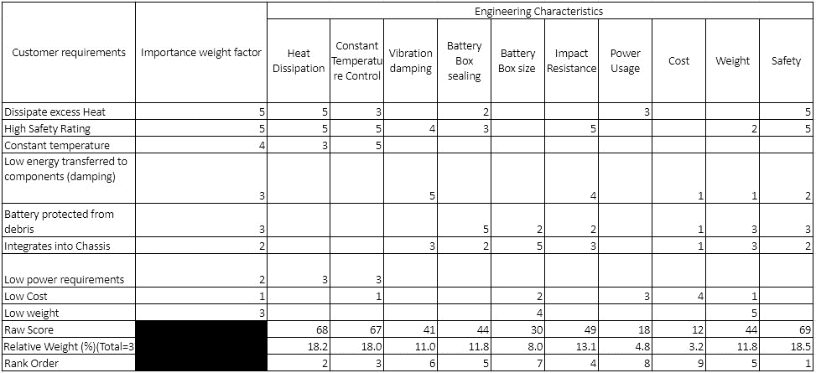

Table 2
First Pugh Chart
Pugh Chart |  | Concepts
Engineering Characteristics | Nissan Leaf Battery Pack | Passive Air Cooling | Forced Air Cooling | Liquid Cooled w/ Compressive Plates | Cold Plate | Phase Change Material
Heat Dissipation | Datum | S | + | + | + | S
Constant Temp Control |  | S | + | + | + | +
Power Usage |  | + | - | - | - | +
Vibration Damping |  | + | - | - | - | +
Box Sealing |  | S | - | S | S | S
Box Volume |  | + | S | - | S | +
Impact Resistance |  | + | - | - | + | -
Cost |  | S | S | - | - | -
Weight |  | S | + | - | S | -
Safety |  | S | S | - | + | -
# of pluses (+) |  | 4 | 3 | 2 | 4 | 4
# of minuses (-) |  | 0 | 4 | 7 | 3 | 4

Table 3
Second Pugh Chart
Pugh Chart |  | Concepts
Engineering Characteristics | Passive Air Cooling | Forced Air Cooling | Cold Plate | Phase Change Material
Heat Dissipation | Datum | + | + | S
Constant Temp Control |  | + | + | +
Power Usage |  | - | - | S
Vibration Damping |  | - | - | +
Box Sealing |  | - | S | S
Box Volume |  | S | S | S
Impact Resistance |  | - | + | S
Cost |  | S | - | -
Weight |  | + | + | -
Safety |  | S | S | -
# of pluses (+) |  | 3 | 4 | 2
# of minuses (-) |  | 4 | 3 | 3

Table 4
Third Pugh Chart
Pugh Chart |  | Concepts
Engineering Characteristics | Cold Plate | Forced Air Cooling | Passive Air Cooling | Phase Change Material
Heat Dissipation | Datum | + | + | S
Constant Temp Control |  | - | - | -
Power Usage |  | + | + | +
Vibration Damping |  | - | S | S
Box Sealing |  | - | S | S
Box Volume |  | - | S | S
Impact Resistance |  | - | S | +
Cost |  | + | + | -
Weight |  | + | S | +
Safety |  | - | + | -
# of pluses (+) |  | 4 | 4 | 3
# of minuses (-) |  | 6 | 1 | 3

Table 5
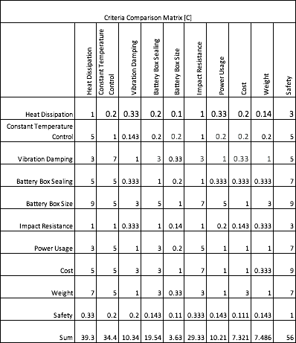
Criteria Comparison Matrix

Table 6
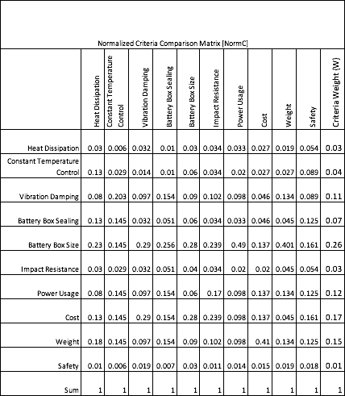
Normalized Criteria Comparison Matrix
Table 7
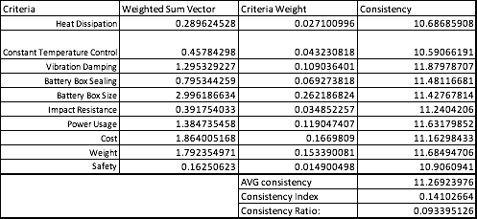
Consistency check

AHP Characteristic Rating:
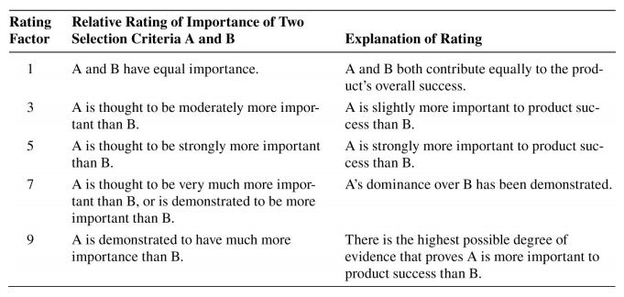

Figure 1. Criteria for rating the engineering characteristics in the AHP.

